**React Assignment:2**

1. **Apply the concept of conditional rendering,to display the Login Component if the user is not logged in, or display the NumberList component if he or she is logged in.**

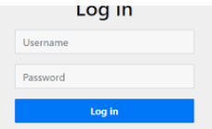

**NumberList View**

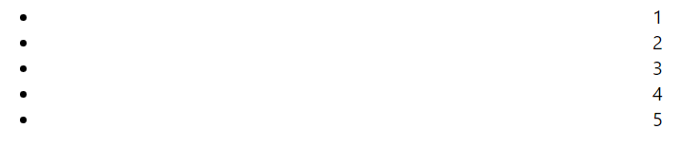

1. **import** React, { Component } **from** "react";
2. **export** **default** *class* NumberList *extends* Component {
3. state **=** { value: [1, 2, 3, 4, 5] };
4. render() {
5. *let* { value } **=** *this***.**state;
6. *const* style **=** {
7. height: "100vh",
8. width: "50%",
9. margin: "auto",
10. };
11. *const* list **=** {
12. position: "absolute",
13. padding: "0%",
14. };
15. *const* itemlist **=** {
16. position: "absolute",
17. right: "25%",
18. };
19. *return* (
20. <**div** *style***=**{style}>
21. <**form**>
22. <**h2**>Number List</**h2**>
23. <**ul**>
24. {value**.**map((v) *=>* {
25. *return* (
26. <**li**>
27. <**span** *style***=**{itemlist}>{v}</**span**>
28. </**li**>
29. );
30. })}
31. </**ul**>
32. </**form**>
33. </**div**>
34. );
35. }
36. }
37. **Create a UI for the below State data. Create Component named TableRow that accepts state data as the props and renders each item as as a Table Row.**

**this.state = {**

**data:**

**[**

**{**

**"id":1,**

**"name":"Foo",**

**"age":"20"**

**},**

**{**

**"id":2,**

**"name":"Bar",**

**"age":"30"**

**},**

**{**

**"id":3,**

**"name":"Baz",**

**"age":"40"**

**}**

**]**

**}**

**import** React **from** "react";

**export** **default** *class* TableRow *extends* React**.**Component {

  constructor(props) {

    super(props);

  }

  render() {

*return* (

      <**tr** *style***=**{*this***.**props**.**style}>

        <**td** *style***=**{*this***.**props**.**style}>{*this***.**props**.**componentData**.**id}</**td**>

        <**td** *style***=**{*this***.**props**.**style}>{*this***.**props**.**componentData**.**name}</**td**>

        <**td** *style***=**{*this***.**props**.**style}>{*this***.**props**.**componentData**.**age}</**td**>

      </**tr**>

    );

  }

}

**import** React **from** "react";

**import** TableRow **from** "./TableRow.js";

**export** **default** *class* Table *extends* React**.**Component {

  constructor() {

    super();

*this***.**state **=** {

      data: [

        {

          id: 1,

          name: "Foo",

          age: "20",

        },

        {

          id: 2,

          name: "Bar",

          age: "30",

        },

        {

          id: 3,

          name: "Baz",

          age: "40",

        },

      ],

    };

  }

  render() {

*const* style **=** {

      height: "50vh",

      width: "50%",

      margin: "auto",

    };

*const* table **=** {

      border: "1px solid black",

      margin: "auto",

    };

*return* (

      <**div** *style***=**{style}>

        <**table** *style***=**{table}>

          <**tr**>

            <**th** *style***=**{table}>ID</**th**>

            <**th** *style***=**{table}>NAME</**th**>

            <**th** *style***=**{table}>AGE</**th**>

          </**tr**>

          {*this***.**state**.**data**.**map((dynamicComponent, i) *=>* (

            <**TableRow** *style***=**{table} *key***=**{i} *componentData***=**{dynamicComponent} />

          ))}

        </**table**>

      </**div**>

    );

  }

}